**2.1 Spur Gear Selection Flow Chart**

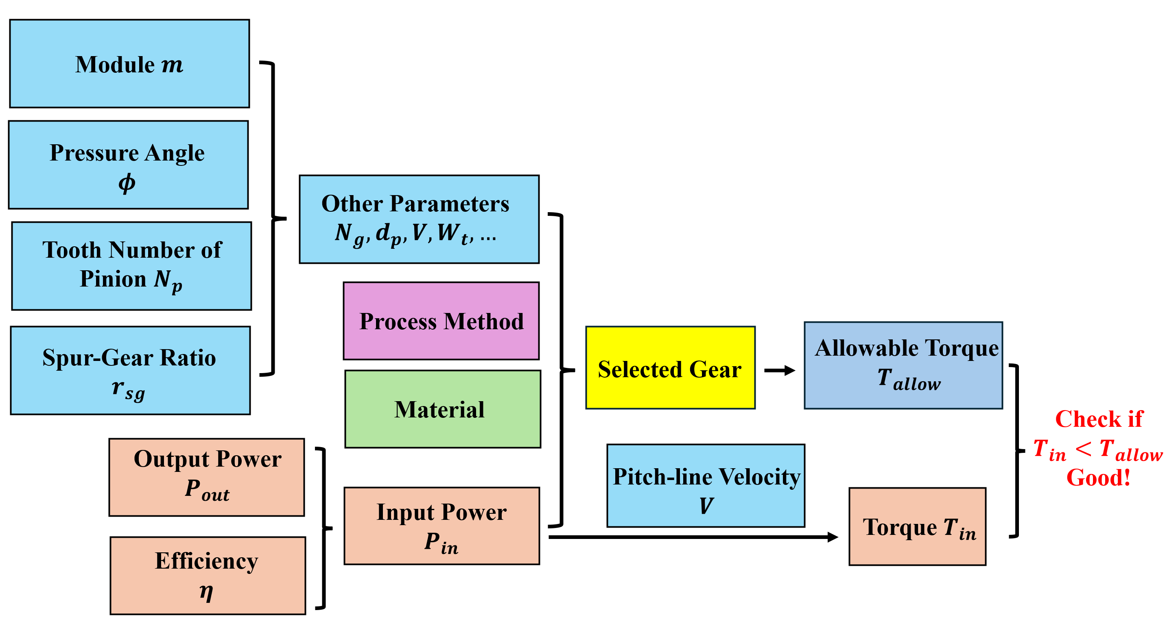

**Figure 2.1.1** Durian picker machine end-effector spur-gear selection flow chart.

**2.2 Power Relationships of Spur Gear and End-effector**

Since we lack an exact cut-off force value about the durian branch, here we assign a significantly sufficient value to the cut-off force ensuring that desired motion is achieved. The durian picking task is not strict with the speed requirements of the end-effectors, therefore we select a nice angular speed to fit our need, which represents the end-effector rotating rads in seconds, i.e., . Length of end-effector is . Power applied on the end-effector is . Considering that power losses between pinion, and that gear and its efficiency generally varies between , we choose an efficiency coefficient . Thus, the power subjected to the pinion is known as .

**2.3 Teeth Number Determination of Spur Pinion and Gear**

When two gears are in mesh, it is possible that an involute portion of one will contact a non-involute portion of the other gear. This phenomenon is known as "interference" and occurs when the number of teeth on the smaller of the two meshing gears is less than a required minimum.

**2.3.1 The Determination of Teeth Number of Spur Pinion Without Interference**

To avoid the interference between gears, it is necessary to determine the smallest teeth number of spur pinion (refer to Shiley eq.13-10), where for full-depth teeth and is the pressure angle we decide. Then we find that the smallest teeth number of the spur pinion without interference is 13. For safety consideration, a considerable teeth number of gears is more welcome in our design. **Therefore, we choose the teeth number of spur-gear is** .

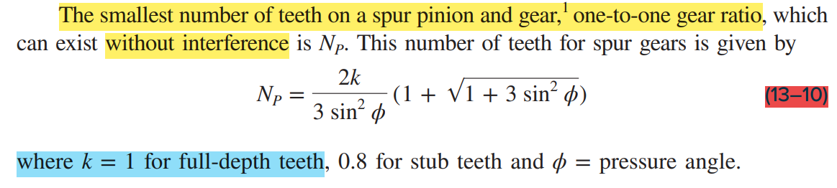

**2.3.2 The Determination of Teeth Number of Gear Without Interference**

Since the teeth number of gear cannot be infinite, the maximum teeth number of gear is determined with the help of Shigley eq.13-12.

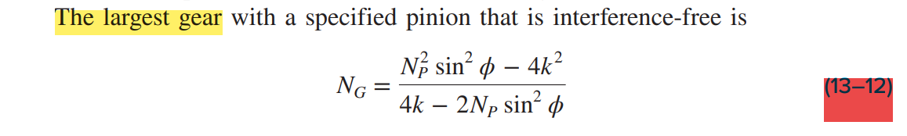

It means that if the teeth number of gear does not exceed 45, then the selected gear will not encounter interference phenomena. **Since we set the spur-gear ratio is 1, the teeth number of the gear should be the same as pinion’s, i.e., 15.**

**2.4 Theoretical Torque Calculation**

Before we realize the theoretical torque applied to the pinion, we need to know the pitch-line velocity and tangent force between the gearset.

**2.4.1 Pitch-line Velocity**

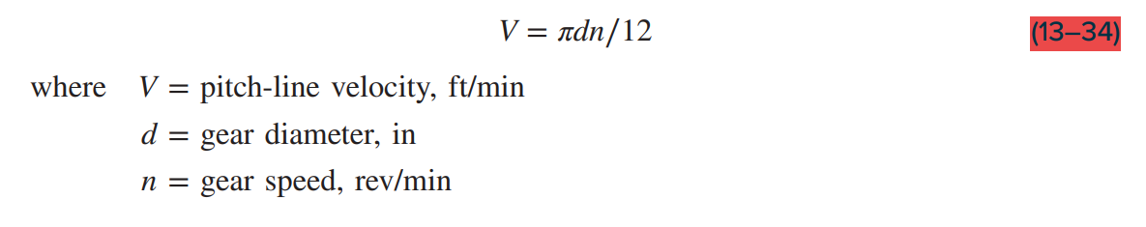

**2.4.2 Tangent Force**

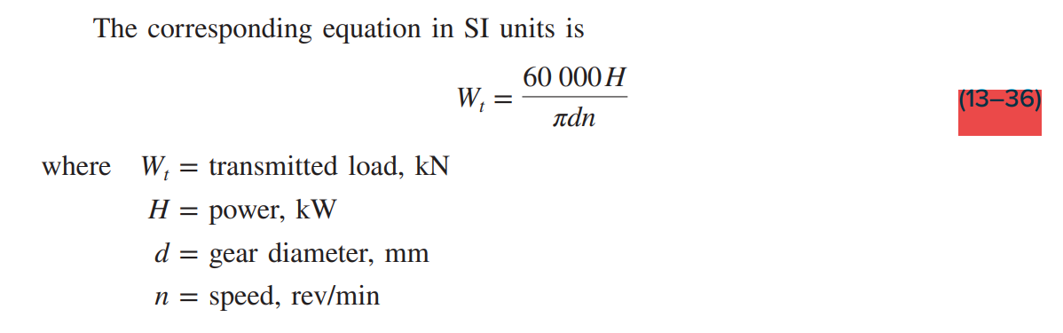

**2.4.3 Theoretical Torque Applied to the Pinion**

**2.5 Spur-Gear Selection**

A gearset (GEAKB2.0-15-20-A-12N) provided by a Japanese company, MiSUMi, fit our need. Here are all relevant parameters.

**Table 2.5.1** Spur-Gear Parameters.

|  |  |  |  |  |  |  |
| --- | --- | --- | --- | --- | --- | --- |
| Module [mm] | Teeth Number | Teeth Width [mm] | Key Size | Material | Specific Process | Allowable Torque [Nm] |
| 2 | 15 | 20 | 12N | S45C | \ | 28.65 |

More details please check the link below:

https://www.misumi.com.cn/linked/archive/ebook/fabiaozhunpin202210/index.html#/ebook?catalogName=fabiaozhunpin202210&images=23-0308_1189,23-0308_1190&pdfs=1151,1152&targetPage=1152

**Figure 2.5.1** Tolerance of the keyway.

**Figure 2.5.2** Other information about the gear.

**2.6 Examine the Failure of Gearset**

Refer to Table 2.5.1, we know the allowable torque tested in experiment from MiSUMi company, then we can compare the allowable torque and the theoretical torque we calculated . If the theoretical torque is smaller than the allowable torque , we successfully select the gear. Otherwise, we need to choose a new one.

**We successfully choose a desired gear, which is GEAKB2.0-15-20-A-12N!**

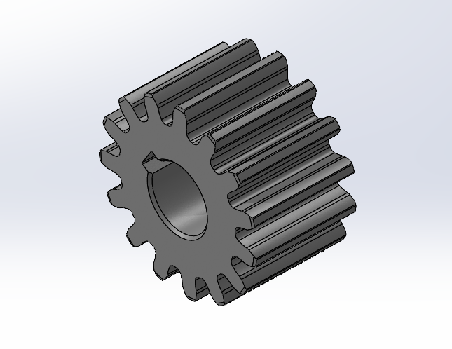

**Figure 2.6.1** Spur-Gear GEAKB2.0-15-20-A-12N (MiSUMi).